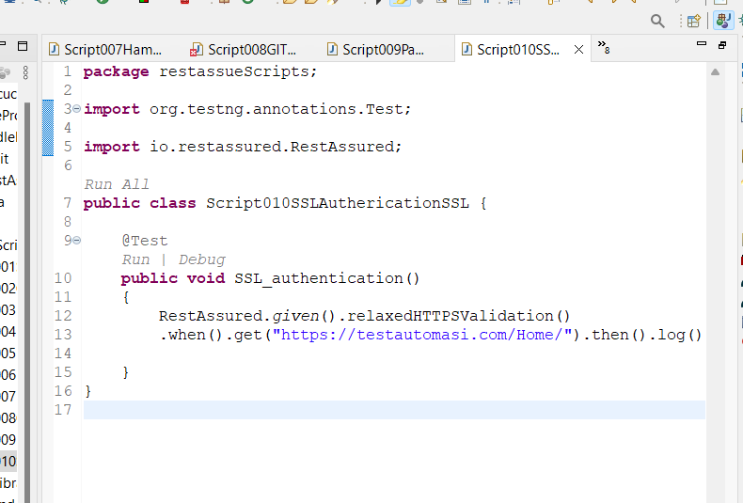

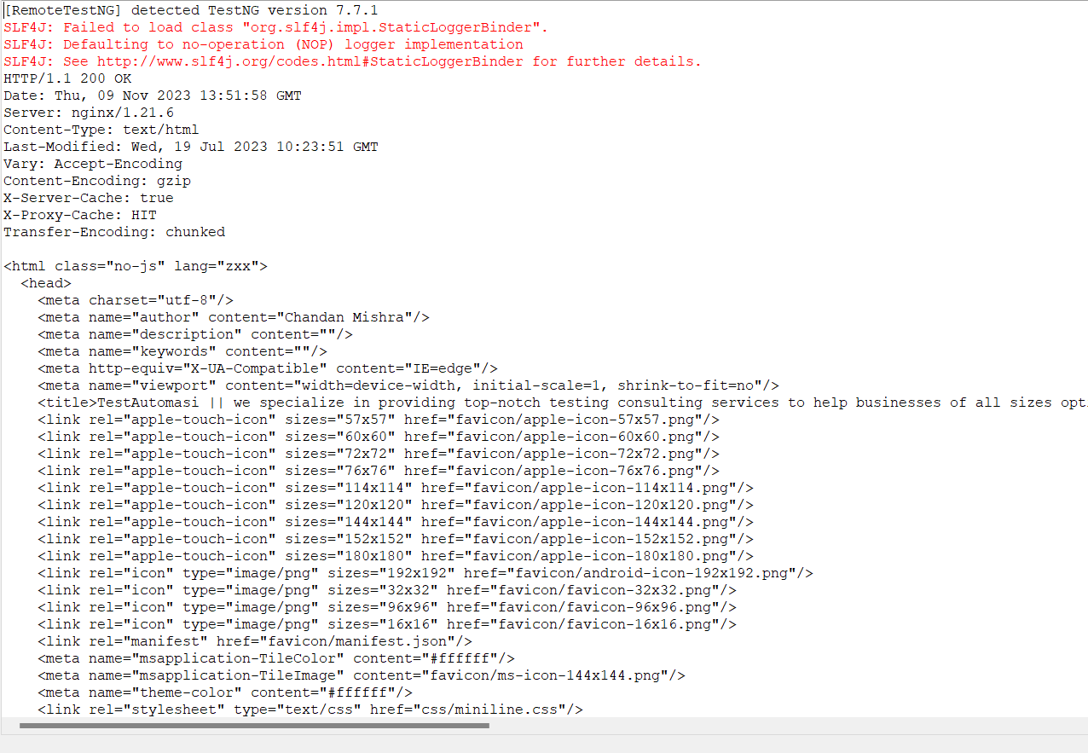

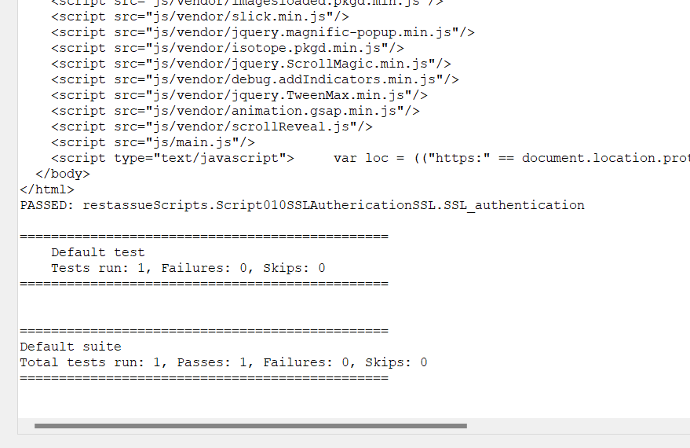

**package** restassueScripts;

**import** org.testng.annotations.Test;

**import** io.restassured.RestAssured;

**public** **class** Script010SSLAuthericationSSL {

@Test

**public** **void** SSL_authentication()

{

RestAssured.*given*().relaxedHTTPSValidation()

.when()

.get("https://testautomasi.com/Home/")

.then()

.log().all();

}

}